ELECENG 3TP3
Lab #2 Report
Instructor: Dr. Kiruba
Jasmine Dosanjh – dosanj5 – 400531879
Warisha Noushad – noushadw – 400519903
November 4, 2025

Question 1: Convolution
- (a)
To manually find the convolution $y\left[n\right]=x\left[n\right]*v\left[n\right]$ for all $n≥0$, $v\left[m\right]$ was flipped to $v\left[-m\right]$ and shifted by $n$ to get $v\left[n-m\right].$ Then element by element multiplication and summation were performed to sketch the final result $y\left[n\right]$.
(a)
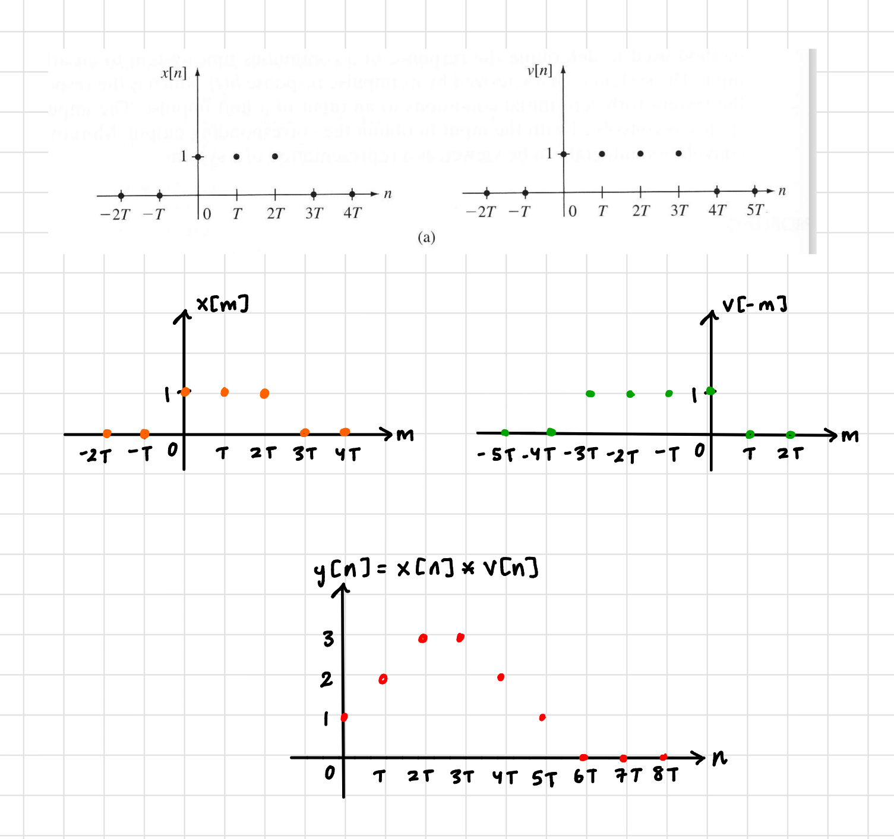
Figure 1. Convolution for (a)
$$y\left[0\right]=1$$
$$y\left[T\right]=1+1=2$$
$$y\left[2T\right]=1+1+1=3$$
$$y\left[3T\right]=1+1+1=3$$
$$y\left[4T\right]=1+1=2$$
$$y\left[5T\right]=1$$
$$y\left[n\right]=0 otherwise$$
(b)
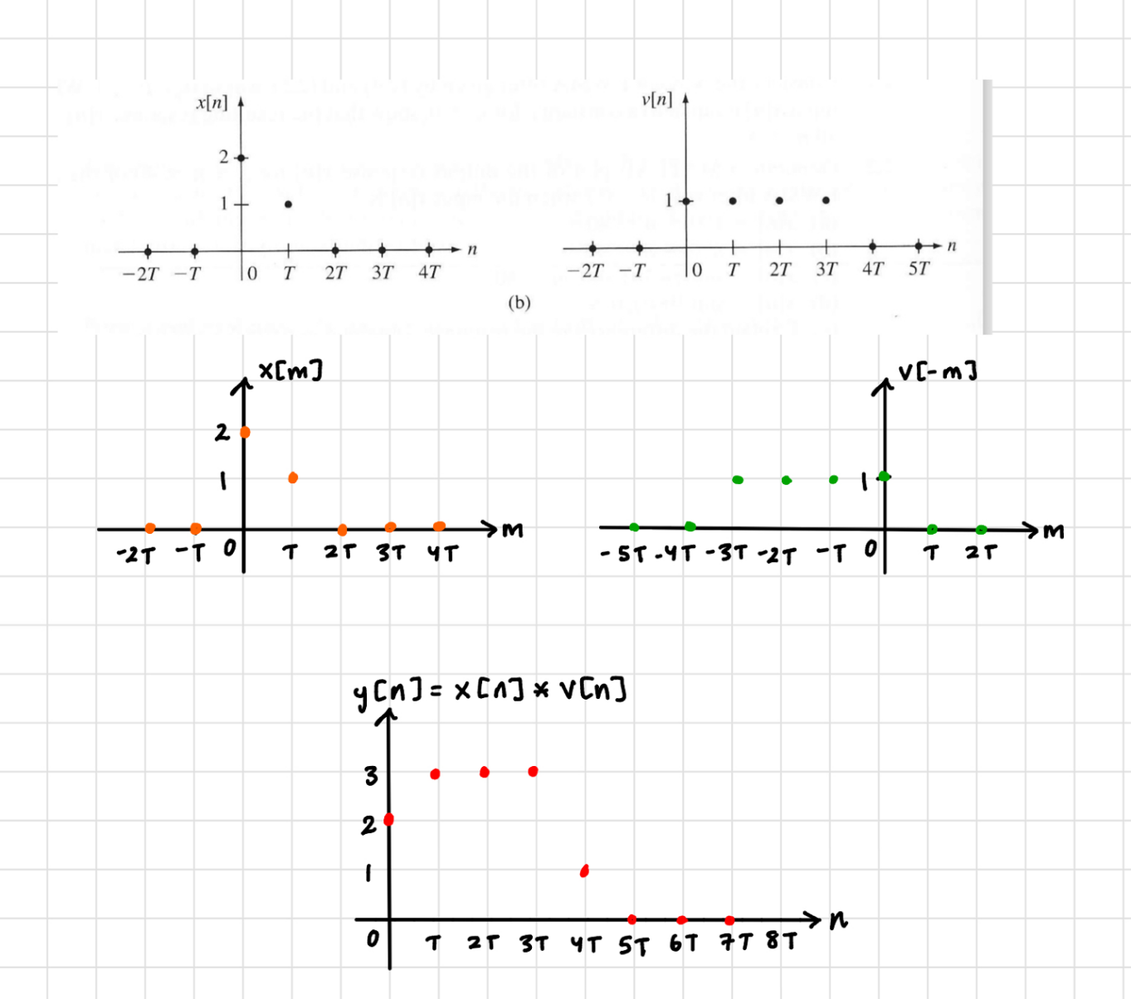
Figure 2. Convolution for (b)
$$y\left[0\right]=1\left(2\right)=2$$
$$y\left[T\right]=1\left(2\right)+1(1)=3$$
$$y\left[2T\right]=1\left(2\right)+1(1)=3$$
$$y\left[3T\right]=1\left(2\right)+1(1)=3$$
$$y\left[4T\right]=1(1)=1$$
$$y\left[n\right]=0 otherwise$$

(c)
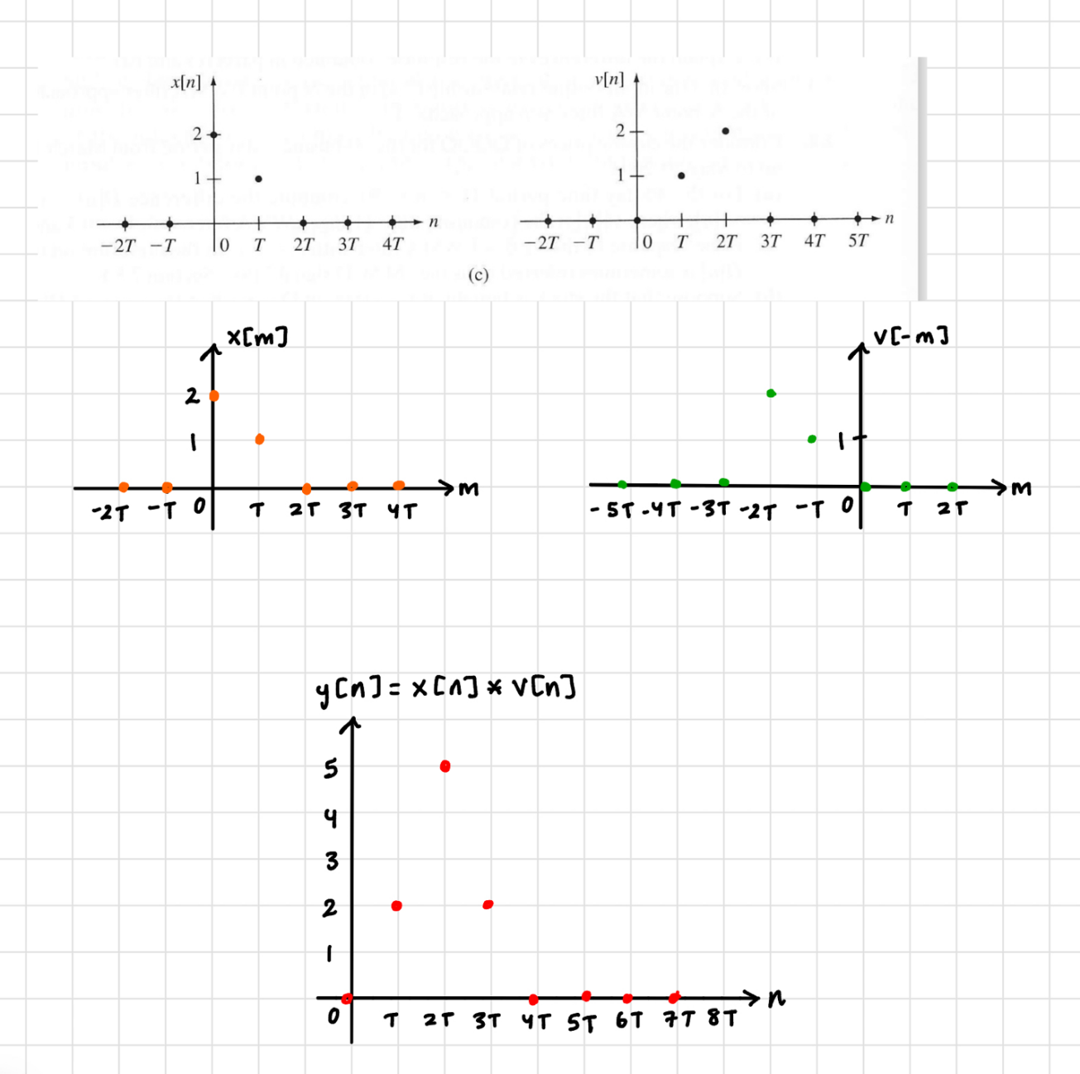
Figure 3. Convolution for (c)
$$y\left[T\right]=1\left(2\right)=2$$
$$y\left[T\right]=2\left(2\right)+1(1)=5$$
$$y\left[2T\right]=1\left(2\right)=2$$
$$y\left[n\right]=0 otherwise$$
- (b)
The MATLAB code to verify the results from Part (a) is included below. The script assigns the data for each signal into a vector and finds the convolution of the vectors $x\left[n\right]*v\left[n\right]$.
Listing 1: Assigning Variables
1. xa = [1 1 1]; xb = [2 1]; xc = xb;
2. va = [1 1 1 1]; vb = va; vc = [0 1 2];
3.
4. ya = conv(xa,va);
5. yb = conv(xb,vb);
6. yc = conv(xc,vc);

The MATLAB code to plot and export each vector is included below. It uses the MATLAB subplot feature to output a plot per vector and display it.
Listing 2: Stem Plots
1. t = tiledlayout(3, 3);
2. title(t, {'Jasmine Dosanjh 400531879', 'Warisha Noushad 400519903'});
3.
4. nexttile; % Plot 1
5. stem(0:length(xa)-1,xa); title('(a) x[n]'); axis([0 3 0 2]);
6.
7. nexttile; % Plot 2
8. stem(0:length(va)-1,va); title('v[n]'); axis([0 4 0 2]);
9.
10. nexttile; % Plot 3
11. stem(0:length(ya)-1,ya, 'r'); title('x[n]*v[n]'); axis([0 6 0 4]);
12.
13. nexttile; % Plot 4
14. stem(0:length(xb)-1,xb); title('(b) x[n]'); axis([0 2 0 3]);
15.
16. nexttile; % Plot 5
17. stem(0:length(vb)-1,vb); title('v[n]'); axis([0 4 0 2]);
18.
19. nexttile; % Plot 6
20. stem(0:length(yb)-1,yb, 'r'); title('x[n]*v[n]'); axis([0 5 0 4]);
21.
22. nexttile; % Plot 7
23. stem(0:length(xc)-1,xc); title('(c) x[n]'); axis([0 2 0 3]);
24.
25. nexttile; % Plot 8
26. stem(0:length(vc)-1,vc); title('v[n]'); axis([0 3 0 3]);
27.
28. nexttile; % Plot 9
29. stem(0:length(yc)-1,yc,'r'); title('x[n]*v[n]'); axis([0 4 0 6]);
30. yticks(0:2:6); % Force 0,1,2,3,4,5
31.
32. exportgraphics(gcf, 'Q1_stem_plots.jpg');

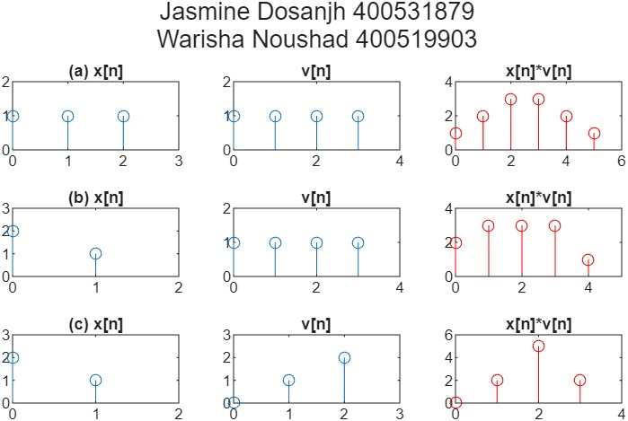
Figure 4. Part 1b Stem Plots

Question 2: Audio Recording
- The MATLAB code is included below; it generates the following distorted signal:
$$\begin{aligned}f_{r}\left(t\right)=f_{s}\left(t\right)+ af_{s}\left(t-t_{e}\right)\end{aligned}\left(1\right)$$
First, the audio file was stored in the vector signal, with its sample frequency set to Fs. The signal collapsed from a stereo vector (688128×2) to a mono vector (688128×1).
Listing 3: Original Signal
1. [signal, Fs] = audioread('my_speech_clip.wav')
2. signal = mean(signal, 2);
3.
4. L = length(signal) % Number of samples in the signal.
5. T = 1/Fs % Sampling period in seconds.
6. t = [0:L-1]*T % Time vector in seconds.
Next, the echo delay was set to 1 second. Using the echo delay value, the number of samples being delayed L_delay was found. The echo volume alpha was set to half of the original. A vector called signalplusecho was created, which makes a zero-filled vector large enough to hold both the original and delayed echo. The original signal was copied into samples 1 to L of signalplusecho. Finally, the scaled copy of the signal was inserted with a 1-second delay, which created the distorted echo effect. The output was rescaled to avoid clipping and then exported.
Listing 4: Delayed Signal
1. Te = 1000 % Echo delay in msec
2. Te_sec = Te / 1000
3. alpha = 0.5; % echo volume
4.
5. L_delay = round(Te_sec * Fs) % Number of samples being delayed
6. signalplusecho = zeros(L+L_delay, 1) % create vector
7. signalplusecho(1:L) = signal % insert original signal
8. signalplusecho(L_delay+1:end) = signalplusecho(L_delay+1:end) + alpha*signal; % add delayed echo
11. signalplusecho = signalplusecho/max(abs(signalplusecho)); % re-scale to avoid clipping
12. audiowrite('speechwithecho.wav', signalplusecho, Fs) % new wav file

- From Question 4, equation 1 has the following impulse response:
$$\begin{aligned}h[n]=δ[n]+ aδ\left(n-n_{e}\right)\end{aligned}\left(2\right)$$
This code creates the same distortion effect using convolution. Lines 1-8 remain the same as Question 4. A vector IR was created, which makes a zero-filled vector. At index 1, the original signal $δ[n]$ is placed, and since the amplitude of the Kronecker delta is 1, then IR=[1,0,0…]. At index L_delay+1, alpha is placed, which represents the echo delayed by L_delay samples IR=[1,0,0...0.5]. Finally, the original and echoed signals are convolved, which combines the original signal and its delayed version. Again, the output was rescaled to avoid clipping and then exported.
Listing 5: Distorted Signal Using Convolution
1. [signal, Fs] = audioread('my_speech_clip.wav') % Read in og signal
2. signal = mean(signal, 2);
3.
4. Te = 1000 % Echo delay in msec
5. Te_sec = Te / 1000
6. alpha = 0.5; % echo volume (50% of og volume)
7.
8. L_delay = round(Te_sec * Fs) % Number of samples being delayed
9.
10. IR = zeros(L_delay+1, 1) % create impulse response vector
11. IR(1) = 1 % Original signal δ[n]
12. IR(L_delay+1) = alpha % Echo signal α·δ[t–te]
13.
14. conv_echo_signal = conv(signal, IR); % Convolves original & echoed signal
15.
16. conv_echo_signal = conv_echo_signal/max(abs(conv_echo_signal)); % re-scale to avoid clipping
17. audiowrite('speechwithecho_conv.wav', conv_echo_signal, Fs); % new wav file

- Through experimenting with different values of Te when alpha=1, it was determined that the quality of speech is acceptable around 10ms. At this small delay, the two signals blend into one signal. As alpha decreases, the echo becomes quieter, reducing the effect of the echo. At alpha=0.3, a higher value of Te=100ms is more tolerable. This shows that the relationship between alpha and Te is inversely related. A louder signal requires a smaller delay to blend into the original signal, whereas a quieter signal can have a longer delay as it's less noticeable.
The MATLAB code below creates a reverberation effect by creating several echoes, each at a decreasing amplitude. This code is the same as Listing 5 but includes an additional variable num_echos, which stores the number of echoes and IR being generated differently. The size of IR changed from IR being L_delay+1 to num_echos*L_delay+1, as multiple echoes need to be accounted for instead of one. The echoes are added in a for loop through which alpha exponentially decreases, and at each index i*L_delay+1 another echo is inserted i.e., IR=[1,0.5,0.25...].
i | Index = i*L_delay+1 | Value stored in IR=${alpha}^{i}$
0 | 1 | 1
1 | 2 | 0.5
2 | 3 | 0.25

Finally, the original and reverb signal are convolved, which combines the original signal and its multiple delays. Again, the output was rescaled to avoid clipping and then exported.

1. [signal, Fs] = audioread('my_speech_clip.wav') % Read in og signal
Listing 6: Reverberated Signal
2. signal = mean(signal, 2);
3.
4. Te = 20 % Echo delay in msec
5. Te_sec = Te / 1000;
6. alpha = 0.5; % echo volume (50% of og volume)
7. L_delay = round(Te_sec * Fs); % Number of samples being delayed
8.
9. num_echos = 1000; % number of echos Ne
10.
11. IR = zeros(num_echos*L_delay+1, 1); % create impulse response vector
12. IR(1) = 1 % Original signal δ[n]
13.
14. for i=1:num_echos
15. IR(i*L_delay+1) = alpha^i; % Echo signal α·δ[n – Delay]
16. end
17.
18. signalplusreverb = conv(signal, IR); % Convolves original & echoed signal
19.
20. signalplusreverb = signalplusreverb/max(abs(signalplusreverb)); % re-scale to avoid clipping
21. audiowrite('speechwithreverb_conv.wav', signalplusreverb, Fs); % new wav file
When Ne=1, the signal was the same as that in Question 6, and the observations about Te and alpha remained the same.
Through experimenting with different values of Te, when alpha=1 and Ne=1000, it was determined that the quality of speech is acceptable around 0.002ms. At this small delay, the multiple signals blend into one signal. As alpha decreases, the echo becomes quieter, reducing the effect of the echo. At alpha=0.3, a higher value of Te=200ms is more tolerable.
This shows the relationship between Ne, alpha, and Te. Consistent with part 6, Te and alpha are inversely related, and increasing Ne just amplifies this effect. Multiple louder signals require a very small delay to blend them all into the original signal, whereas multiple quieter signals can have longer delays as the reverberation is less noticeable.

